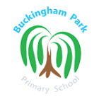
Buckingham Park Primary School

Vision: Learning together. Learning for Life

Mission: Buckingham Park is a safe, vibrant place of learning where children engage enthusiastically with a stimulating and challenging curriculum. All individuals will be valued and enabled to grow and achieve academically, socially and emotionally and develop the skills required for successful future lives in a rapidly changing society.

Remote Education Policy
Policy reviewed | September 2023
Policy to be reviewed | September 2025
Reviewed by: | Assistant Headteacher
Approved by: | Governing Body

1. Background

This policy aims to ensure the continuing provision of learning for children at Buckingham Park Primary School under unusual circumstances. This may include, but is not restricted to, closures for the following reasons: illness epidemic, extreme weather, power-loss and health and safety issues relating to the school site.

2. Remote learning lead and monitoring

The Senior Leadership Team (SLT) are responsible for formulating and overseeing the school’s Remote Education Policy. Any questions about the operation of this policy should be addressed, in the first instance, to the Assistant Headteacher for Curriculum and Assessment.

The Governing Body is responsible for monitoring the school’s approach to providing remote learning, ensuring that there is equality of provision across home and school learning environments and that this adheres to the national curriculum as closely as possible, given the circumstances. They will also monitor that SLT have measures in place to ensure that systems are appropriately secure, for both data protection and safeguarding reasons.

3. Preparing for remote education

Buckingham Park Primary School will ensure that:
- Teaching staff have secure remote access to Google Classroom (and any other platforms specific to their year group) and are trained in the use of these
- All children have login and password details in order to Google Classroom and have been provided with clear guidance on how to use this at home
- Children who do not have access to the technology and/or skills to operate this will be provided with a laptop (subject to availability/need) or printed materials to complete comparable learning offline
- Parents/carers and children will be made aware in advance, or as soon as practicable, of the arrangements in place for remote learning and expectations of work to be completed
- Parents/carers, children and staff are given clear guidance on online safety and data protection/confidentiality issues

Staff will ensure that:
- They have received appropriate training and have all the required login details for the online systems in use for their year group
- Their computer- based teaching resources are available outside of school
- They have access to a suitable secure device for home use and if this is not the case, staff should notify the school bursar immediately

Parents/carers and children should ensure, wherever possible, that they:
- Have access to a tablet, laptop or computer with an internet connection, in order to complete online learning. If this is not the case, parents/carers should notify the Headteacher so that alternative provision can be provided without delay
- Have details of their child’s Google Classroom login and password. If you do not, contact the school office for this information
- Are able to set aside structured time every day for learning in a quiet and calm environment
- Have learning materials available, such as pens, pencils, paper, glue etc.

4. Continuity of education in the event of a closure

Buckingham Park Primary School will make provision for remote contact with children in the following ways:
- Children will have access to work that allows them to continue curriculum progress while at home
- Children will have regular online contact from their class teacher (or another appropriate member of staff where this is not possible), who will provide support and feedback on work during school working hours (8:45am-3:15pm)
- Class teachers will check in with children and their parents/carers by telephone on a weekly basis to monitor their well-being and any additional support required
- Guidance will be given on expectations of structured work to complete, however it is appreciated that ability to do this will vary due to individual circumstances. Any concerns or difficulties should be raised with the class teacher as soon as possible
- Other learning resources, such as Oak Academy, Oddizzi and BBC Bitesize will be signposted as either additional or alternative ways to access the curriculum
- Parents/carers of children with SEND will be contacted separately by the SENCo to provide tailored work and support (see section 9)

We are mindful of the challenges of operating in an unfamiliar environment in that:
- online learning operates on a very different dynamic and may suit some learners better than others
- some subjects and activities do not lend themselves well to remote learning
- learners will have differing skills and/or access to technology

Parents/carers should contact their child’s class teacher through the school office if they have any concerns regarding this.

5. Remote education practice and recommendations

- Google Classroom will be the main hub for all remote learning interactions
- When taking part in a virtual lesson, we recommend that children wear headsets to improve their listening and engagement
- If remote working/learning is happening nationally, then there may be bandwidth restrictions across the UK internet and/or connectivity issues. If this situation arises and is an ongoing issue the school will consider alternative offline provision
- Children will be asked to submit some of their work for marking and feedback to gauge progression/understanding and provide motivation
- Where possible, structured time is set aside every day for learning in a quiet and calm environment
- Parents/carers will notify their child’s teacher if they are unable to complete work or are struggling with it in any way
- Parents/carers will make the school aware if their child is unwell and unable to complete work
- Parents/carers are respectful in raising any issues and use the correct channels for any queries/complaints, e.g. contacting the school office
- Where possible, work will be sent in a PDF format

6. Setting work
- Work will be set for the children to complete across a number of different subjects (See Appendix B)
- Teachers will not be expected to plan new units of work; instead staff will source from the Shared Drive: Planning, the core and curriculum short term plans for that week, and use these to modify the existing notebooks and resources, which will be uploaded and set as remote learning tasks and inputs
- At the start of each week, a teacher will share a post within each ‘classroom’ to provide a summary of the learning taking place that week. The teacher may choose to share extra resource links within this post
- Lesson slides and tasks will then be uploaded and shared with the children daily - these should be clearly organised within curriculum subjects and labelled with the day/date and learning intention (See Appendix C)

7. Expectations in Reception and Key Stage 1

Year group teachers will be responsible for the setting and marking of work within their year, based on existing school long term plans.

Curriculum: Ready for 9 a.m. the curriculum input and task for the day will be uploaded by the relevant teacher and made available to children. The main input can be assigned to the whole year group, but tasks are to be differentiated and assigned to individual children, as required.

Reading: Children will be expected to read daily and complete class reader activities, as directed by the class teacher.

Phonics: Children will be directed to RWI. Phonics resources and activities, differentiated to their ability.

Maths and English: Ready for 9 a.m. the curriculum input and task for the day will be uploaded by the relevant teacher and made available to pupils. The main input can be assigned to the whole year group, but tasks are to be differentiated and assigned to individual children/streamed groups.

Expectations of staff:
- Each day, three lessons (maths, English and other curriculum areas) will be uploaded and linked to the set tasks
- Two guided reading sessions a week are to be set by each class teacher
- Three ‘RWI’ phonics sessions a week exploring phonics sounds are to be set by each class teacher
- Daily maths, English, curriculum and reading tasks will be set on Google Classroom - these will be differentiated within classrooms

Expectations of pupils:
- A daily maths, English, curriculum and phonics/reading task is to be completed and submitted
- Work is to be completed on the day that it is set and by 3:15pm at the latest, to allow time for same day marking and feedback before the next lesson

8. Expectations in Key Stage 2

Year group teachers will be responsible for the setting and marking of work within their year, based on existing school long term plans.

Curriculum: Ready for 9 a.m the curriculum input and task for the day will be uploaded by the relevant teacher and made available to students. The main input can be assigned to the whole year group, but tasks are to be differentiated and assigned to individual children, as required.

Reading: Children will be expected to read daily and complete class reader activities, as directed by the class teacher.

Maths and English: Ready for 9am, the curriculum input and task for the day will be uploaded by the relevant teacher and made available to students. The main input can be assigned to the whole year group, but tasks are to be differentiated and assigned to individual children, as required. NB: The teacher for each Maths streamed group will be responsible for the setting and marking of work within these classrooms based on existing school long term plans.

Expectations of staff:
- Each day, three lessons (maths, English and curriculum) will be uploaded, linked to the tasks set
- Two guided reading sessions a week are to be set by each class teacher
- Daily maths, English, curriculum and reading tasks will be set on Google Classroom - these will be differentiated within classrooms

Expectations of pupils:
- A daily maths, English and curriculum task should be completed and submitted on-line
- Work is to be completed on the day that it is set and by 3:05pm at the latest, to allow time for same day marking and feedback before the next lesson

9. SEND pupils and support

Class teachers (with support from the SENCo) will offer learning adaptations to support children with additional needs who are learning remotely. For children who usually have 1:1 support in school, a weekly video call with their INA will be offered, subject to staff availability.

The SENCo will keep in contact with the families of children who have an EHCP, on a weekly basis. The SENCo will also liaise with external professionals, such as Speech & Language, the Literacy Support Service and Occupational therapy to arrange continued support with specialist programmes at home, wherever possible.

10. Marking and feedback

The marking of children’s remote learning will be given the same amount of time it would during a normal school day.

Once a piece of work has been submitted, it will be marked with next steps given, as appropriate. This marking and feedback will provide children with daily contact with their teacher.

Throughout the working day, staff should be present on DB Learning/Google Classroom and will be expected to be contactable during set timetabled slots, to answer any subject specific questions from children.

Expectations of staff:
- Staff will mark the children’s work by 9am the next morning to ensure that children can view and action any feedback before completing the next task.
- Of the three tasks set each day, one should be deep marked with next steps provided and two should be light marked (See Appendix D)
- Staff are to promptly respond to children’s questions and provide feedback and support throughout the day

11. Information for parents

Parents can access further useful information/materials in the following places:

School website
https://buckinghamparkschool.co.uk/wsussex/primary/buckinghampark/site/pages/findout/remotelearning
A dedicated ‘Remote Education’ information section, including the following:
- Latest news, including the most recent past copies of the newsletter
- Copies of communication to parents/carers
- Useful links to other learning sites/resources
- Information on online safety and mental well-being
- Local community news and support

A separate information section for children joining the school in Reception, including the following:
- Induction information and new parent packs
- Learning activities to get your child ready for school
- Signposting to other useful sites and resources

12. Data Protection/IT security

When accessing personal data, all staff members will use the secure remote school server on a device that has been checked for the correct antivirus and anti-spyware software by our IT contractor, JSPC. Staff members may need to collect and/or share personal data, such as home email addresses and telephone numbers to contact a child’s parent/carer, as part of the remote learning system. Such collection of data applies to our functions as a school and does not require explicit permissions. While this may be necessary, staff are reminded to collect and/or share as little personal data as possible online.

All staff members will take appropriate steps to ensure that their devices remain secure. This includes, but is not limited to:
- Keeping the device password-protected – strong passwords are at least 8 characters, with a combination of upper and lower-case letters, numbers and special characters (e.g. asterisk or currency symbol)
- Ensuring the hard drive is encrypted – this means if the device is lost or stolen, no one can access the files stored on the hard drive by attaching it to a new device
- Making sure the device locks if left inactive for a period of time
- Not sharing the device among family or friends
- Installing antivirus and anti-spyware software, as guided by our IT contractor JSPC
- Keeping operating systems up to date – always install the latest updates

13. Safeguarding

The following links all provide additional information and support regarding online safety for parents/carers and children:
- Thinkyouknow (advice from the National Crime Agency to stay safe online)
- Internet matters
- LGfL
- NSPCC (support for parents and carers from the NSPCC)
14. Summary

The primary purpose of this policy is to minimise any disruption to learning and ensure the continuity of education for all children at Buckingham Park Primary, should they need to remain at home. By using existing school systems, provision can be quickly put into place and children only need their existing login details and password to access this.

Appendix A: Government guidance for remote education

DfE Providing remote education Non-statutory guidance for schools - January 2023

- In developing these contingency plans, we expect schools to:
- 1.1 use a curriculum sequence that allows access to high-quality online and offline resources and teaching videos, and that is linked to the school’s curriculum expectations
- 1.2 give access to high quality remote education resources
- 1.3 select the online tools that will be consistently used across the school in order to allow interaction, assessment and feedback, and make sure staff are trained in their use
- 1.4 provide printed resources, such as textbooks and workbooks, for pupils who do not have suitable online access
- 1.5 recognise that younger pupils and some pupils with SEND may not be able to access remote education without adult support, and so schools should work with families to deliver a broad and ambitious curriculum

- When teaching pupils remotely, we expect schools to:
- 2.1 set assignments so that pupils have meaningful and ambitious work each day in a number of different subjects
- 2.2 teach a planned and well-sequenced curriculum so that knowledge and skills are built incrementally, with a good level of clarity about what is intended to be taught and practised in each subject
- 2.3 provide frequent, clear explanations of new content, delivered by a teacher in the school or through high quality curriculum resources and/or videos
- 2.4 gauge how well pupils are progressing through the curriculum, using questions and other suitable tasks and set a clear expectation on how regularly teachers will check work
- 2.5 enable teachers to adjust the pace or difficulty of what is being taught in response to questions or assessments, including, where necessary, revising material or simplifying explanations to ensure pupils’ understanding
- 2.6 plan a programme that is of equivalent length to the core teaching pupils would receive in school, ideally including daily contact with teachers

Appendix B: Example weekly timetable - Year 6

Week 1 | English: Information Leaflet | Maths: Fractions | Curriculum
Monday | LO: To retrieve information from an extract (Reading focus)  Input: Watch video input on https://classroom.thenational.academy/lessons/newspaper-reading-comprehension-fact-retrieval  Task: Complete all tasks, both quizzes and worksheets | LO: To identify, describe and represent fractions  Input: Watch video input on https://classroom.thenational.academy/lessons/representing-fractions  Task: Complete all tasks, both quizzes and worksheets | Subject: History  LO: To describe what happened during some key events from World War II and order events on a timeline  Input: Lesson slides  Task: 1) Complete a WWII timeline documenting key events; 2) Research a key event of your choosing and record to what extent it was a turning point in WWII
Tuesday | LO: To retrieve information from an extract (Reading focus)  Input: Watch video input on https://classroom.thenational.academy/lessons/newspaper-reading-comprehension-fact-retrieval-bc1b81  Task: Complete all tasks, both quizzes and worksheets | LO: To understand and describe equivalence  Input: Watch video input on https://classroom.thenational.academy/lessons/understanding-equivalence  Task: Complete all tasks, both quizzes and worksheets | Subject: Computing  LO: To find similarities and differences between bullying and cyberbullying  Input: Lesson slides  Task: Reflect on and answer the questions at the end of the slides - Reflection (slide 16)
Wednesday | LO: To identify features of a text  Input: Watch video input on https://classroom.thenational.academy/lessons/newspaper-reading-comprehension-fact-retrieval-bc1b81  Task: Complete all tasks, both quizzes and worksheets | LO: To find equivalent fractions  Input: Watch video input on https://classroom.thenational.academy/lessons/representing-fractions  Task: Complete all tasks, both quizzes and worksheets | Subject: Science  LO: To recognise and explain how light travels  Input: Lesson slides  Task: Draw an annotated diagram to show how light travels from different light sources and explain how the light is travelling
Thursday | LO: To use direct speech to write quotes  Input: Watch video input on https://classroom.thenational.academy/lessons/newspaper-using-direct-speech-to-write-quotes  Task: Complete all tasks, both quizzes and worksheets | LO: To compare fractions less than one  Input: Watch video input on https://classroom.thenational.academy/lessons/representing-fractions  Task: Complete all tasks, both quizzes and worksheets | Subject: PSHE - Celebrating Difference  LO: To reflect on what is ‘normal’  Input: Lesson slides  Task: Reflect on and record answers to questions in the slides
Friday | LO: To write a newspaper report  Input: Watch video input on https://classroom.thenational.academy/lessons/newspaper-writing-a-newspaper-report  Task: Complete all tasks, both quizzes and worksheets | LO: To compare fractions greater than one  Input: Watch video input on https://classroom.thenational.academy/lessons/representing-fractions  Task: Complete all tasks, both quizzes and worksheets | Subject: Reading  Input: Read the chapter of Letters from the Lighthouse by Emma Carrol, as directed by the class teacher  Task: Answer questions

Appendix C: Example of accessing and using Google Classroom

Google Classroom can be accessed through a free App on either the Apple Store (for Apple devices) or Google Play (for Android devices).
It can also be accessed through the internet on laptops or desktop computers - please click on the following hyperlink https://classroom.google.com/ or type it into the address bar.
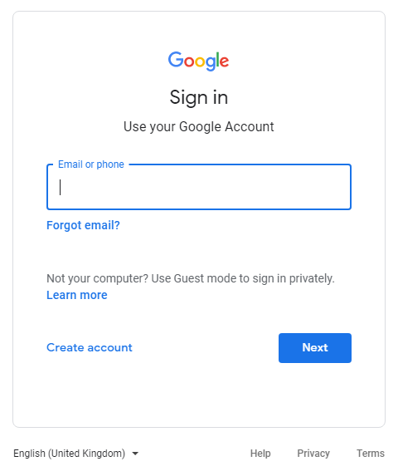 | 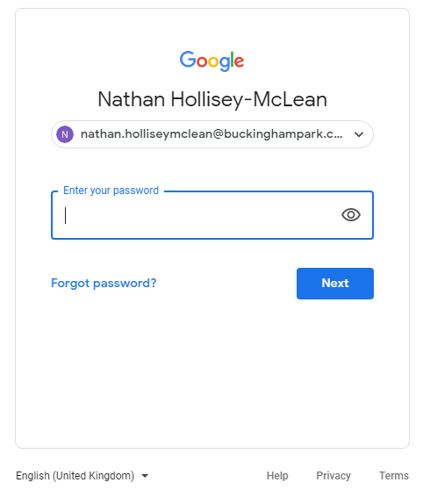
Enter username: child’s name followed by @buckinghampark.co.uk, e.g. Joe.Bloggs@buckinghampark.co.uk | Enter password: this is purposely complicated and cannot be changed, so please keep it safe

The ‘stream’, which is the front page, is where teachers direct children to learning links and websites, and would be the best place for children to explore when they first access their classroom.
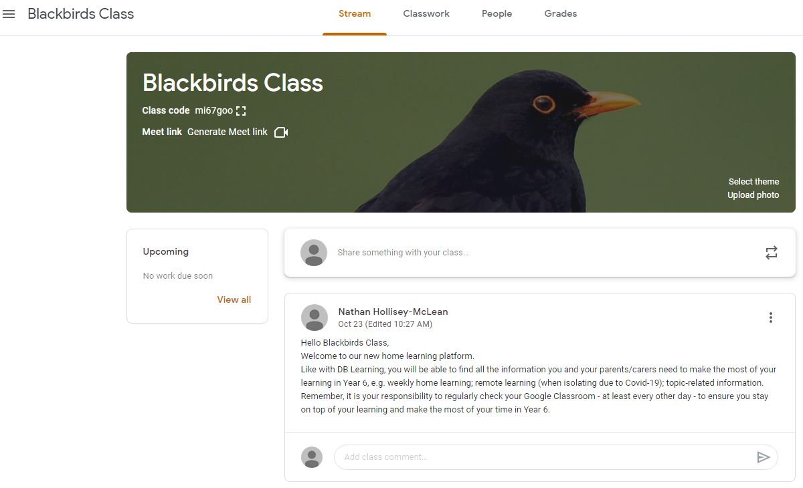
Children will automatically be on the ‘Stream’ page when they login | The children’s class teacher will post comments; sometimes the children will be able to leave a comment too, but not always - the teacher controls this
In the ‘Classwork’ tab, children will find lessons, projects and quizzes/questions that have been set by the class teacher, who will also provide clear instructions explaining how to complete each task.
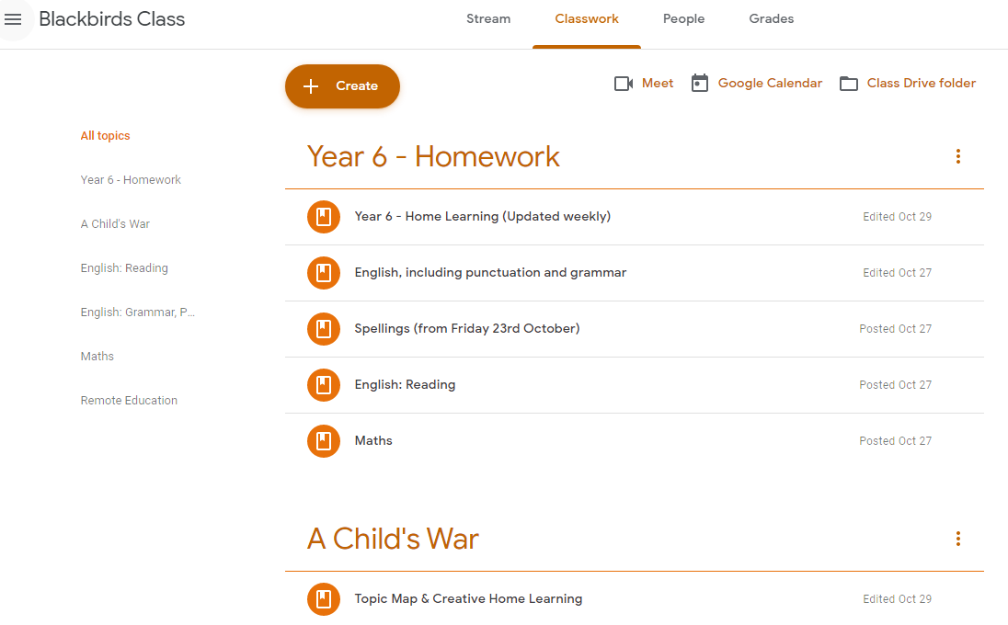
Children need to click on the ‘Classwork’ tab to see the work set by the teacher, including Homework and other learning opportunities | Remote Education will also be under the this tab, should children need to self-isolate due to Covid-19

